EXPT NO 6: Configure firewall in Router Using Cisco Packet Tracer

Objective:
1. To configure a Cisco router as a firewall using Extended Access Control Lists (ACLs).
2. To control communication between secured and untrusted networks by permitting and denying specific network traffic based on defined security policies.
Software/Apparatus required:
(i) Cisco Packet Tracer
(ii) End Devices (PCs)
(iii) Switches
(iv) Copper Straight-through Cable / Automatic Cable Selector
(v) Routers
(vi) Server
Networking Diagram:
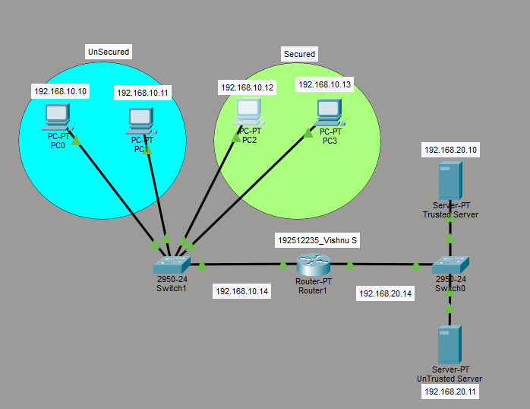

Output:
Sl.  No | Source IP | Destination IP | Data sent (bytes) | Data received  (bytes)
1. | 192.168.10.10 | 192.168.20.11 | 4 | 4(allow)
2. | 192.168.10.11 | 192.168.20.10 | 4 | 4(allow)
3. | 192.168.10.12 | 192.168.20.11 | 4 | 0(deny)
4. | 192.168.10.13 | 192.168.20.10 | 4 | 4(allow)
5. | 192.168.20.11 | 192.168.10.12 | 4 | 0(deny)

Procedure:
1. Design the network topology consisting of:
- Unsecured Network
- Secured Network
- Trusted Web Server
- Untrusted Web Server
- Router acting as a firewall
2. Assign IP addresses to all hosts and router interfaces.
3. Verify basic connectivity using the ping command.
4. Enter global configuration mode on the router:
Router# configure terminal
5. Create an Extended ACL to deny communication between secured hosts and the untrusted web server:
access-list 100 deny ip host 192.168.10.12 host 192.168.20.11
access-list 100 deny ip host 192.168.20.11 host 192.168.10.12
access-list 100 deny ip host 192.168.10.13 host 192.168.20.11
access-list 100 deny ip host 192.168.20.11 host 192.168.10.13
access-list 100 permit ip any any
6. Apply the ACL to the router interface:
interface fa0/0
ip access-group 100 in
7. Exit configuration mode and save the configuration:
end
write
8. Test connectivity:
- Ping the trusted server from all hosts.
- Ping the untrusted server from unsecured hosts.
- Verify that secured hosts cannot ping the untrusted server.
Result:
Objective 1: The Cisco router was successfully configured as a firewall using Extended Access Control Lists (ACLs). The configured ACLs effectively enforced the defined security policies by filtering network traffic between the secured and untrusted networks.
Objective 2: Communication from the secured hosts (192.168.10.12 and 192.168.10.13) to the untrusted web server (192.168.20.11) was successfully blocked, while access to the trusted web server remained available. The unsecured network hosts were able to communicate with both the trusted and untrusted web servers according to the specified security policy.

